**Research Document**

***‘The Big Pitcher’ at the Dingle Animation Festival***

Anastasia Kravale (C00271786)

**Description of project.**

My project is called “The Big Pitcher”. It includes coming up with an animated TV series, a pilot episode, or short film for the Dingle Animation Festival. I will submit my idea by Friday the 9th of February through their website, and hopefully be one of the chosen students to have the chance to pitch the idea at Animation Dingle Conference on 22nd March 2024 to a panel of animation industry experts.

**Interpretation of proposed project plan.**

The goal of the project is to pitch the idea at the Dingle Animation Festival and potentially win. To achieve the goal, I will need to follow a set of tasks.

These include deciding on the animation I want to create, writing a short document explaining my idea, including a title, longline and synopsis. I will also have to draw at least one image of the idea I have created, whether it be the characters or background, etc. I would like to include as many images as I can, making it easier to better understand my pitch.

Finally, once I have done that and submitted through ‘The Big Pitcher’ application form on the Dingle Animation website, by 5pm on 9th February, I will begin working on the actual animation. On 16th February, a week after the submission date, the chosen students for this festival will be announced. With the hopes of being accepted will start working on the presentation, alongside the animation. The pitch will commence on 22nd March. After the Festival I will once again continue working on the animation, no matter the outcome of the pitcher.

**Research.**

I have looked at past winners of ‘The Big Pitcher’ to better understand what it looked like, how the audience reacts, what's being said, etc.

Winner of 2017 festival was Chris Craig: The winner in 2018 was Josh O’Caoimh:

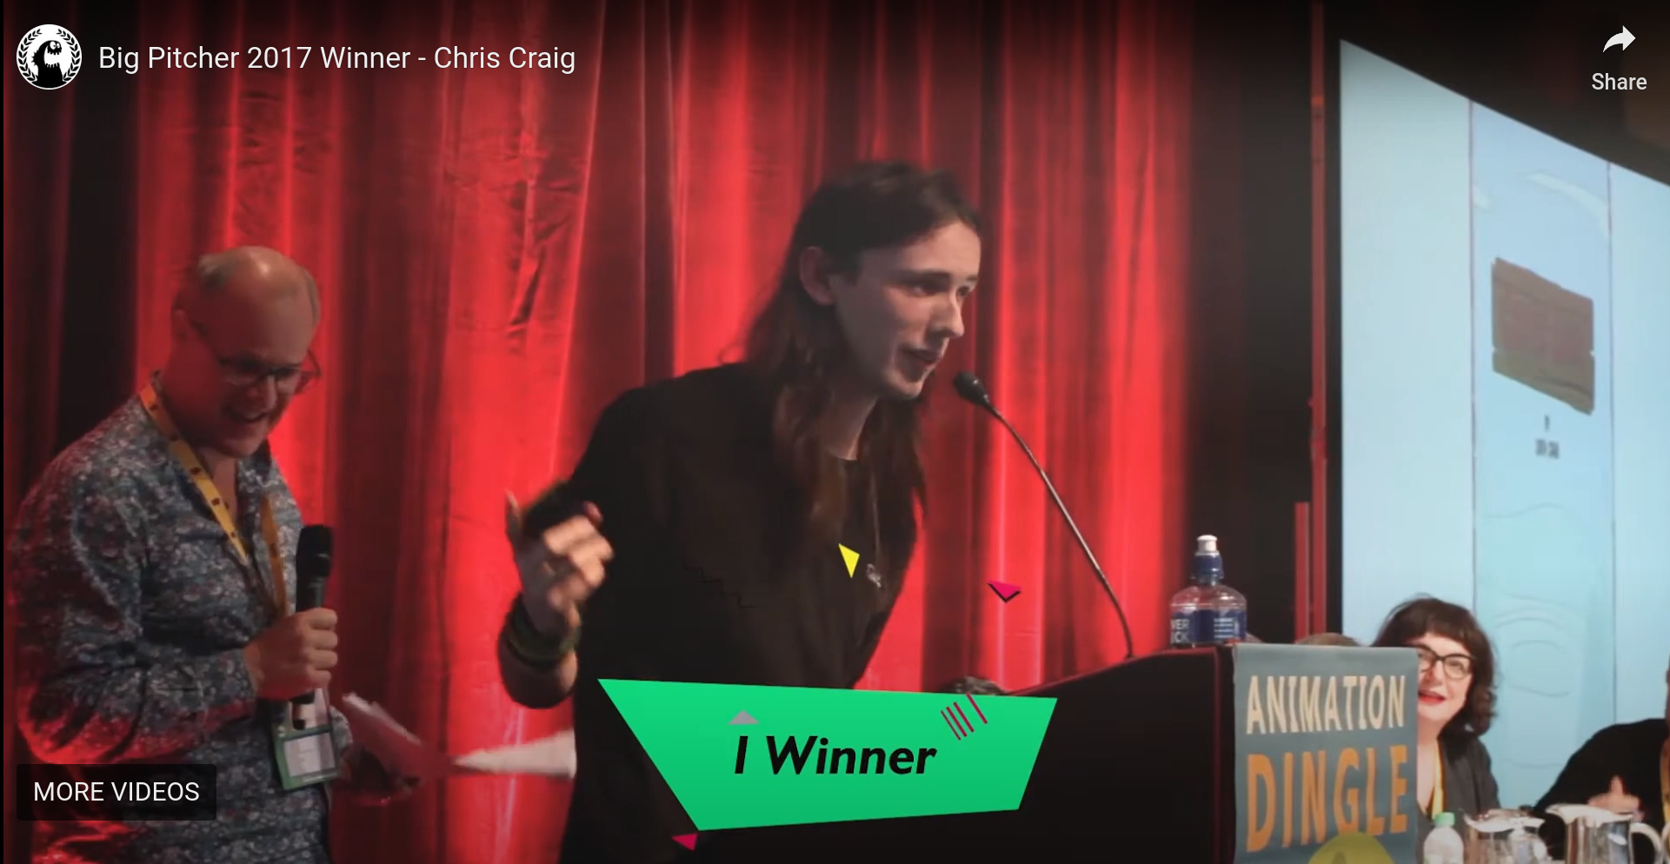 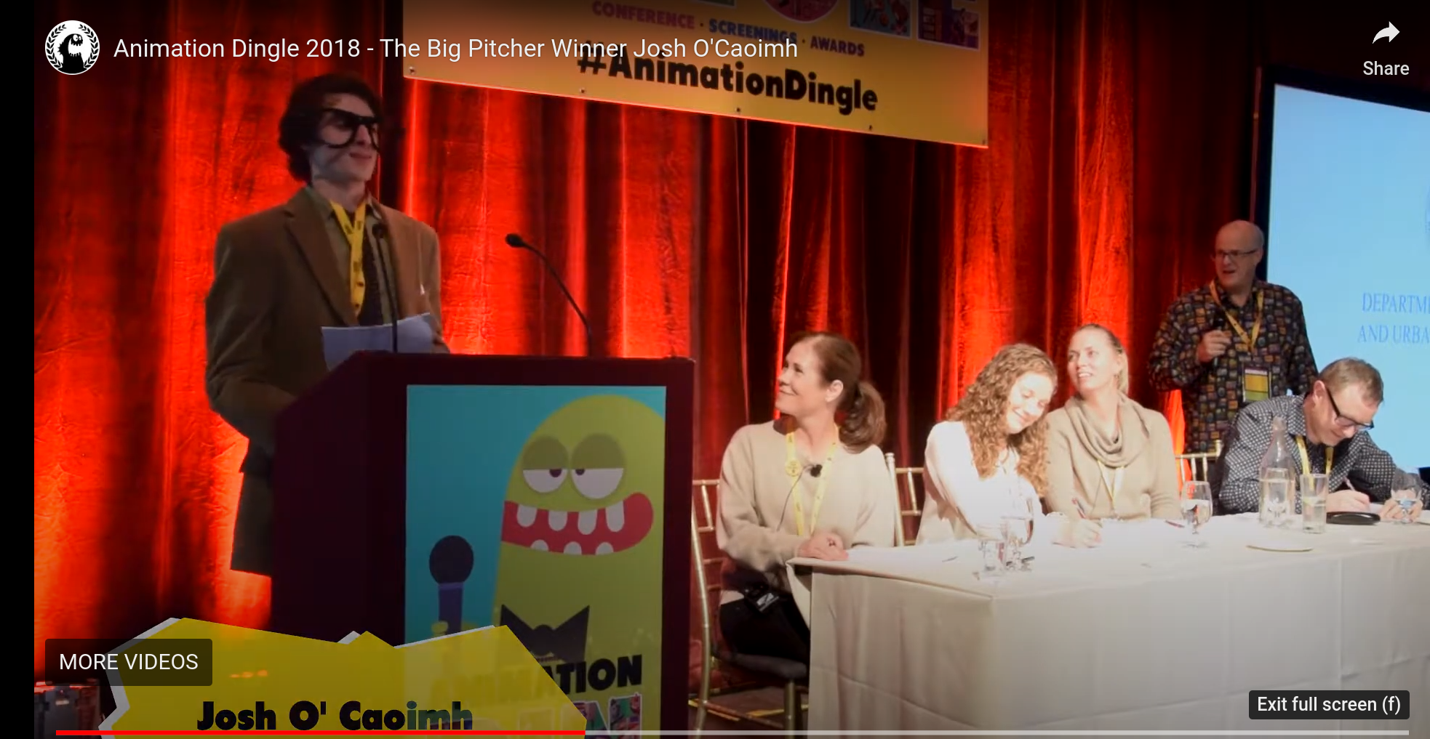

In 2021 the winner was Kirsten Hennessy with the pitch of “Nova”.

The most recent winner of the 2023 Big Pitcher was Fay Antar and her animation “On Eir”.

**Detailed timeline.**

22nd January – 8th February

* Have a set idea of the animation I want to work with.
* Begin writing the description and other notes.
* Have a Title in place, a Longline and Synopsis.
* Draw images to be included in the document, such as the characters, a background, etc.

9th February

* Make sure everything is worded correctly in the document and the images are all good.
* Submit through ‘The Big Pitcher’ application form on the website. By 5pm.

12th February – 16th February

* Start animating my characters and everything else.
* Chosen students are announced on Friday the 16th.

16th February – 21st March

* Working on the presentation for the festival.
* Continue working on the animation.

22nd March

* Pitching my idea at ‘The Big Pitcher’.

25th March – 23rd April

* Continue working on my animation.

**Initial technical requirements.**

For my project I will use the following softwares;

* *Word:* for my written files.
* *Gitlab:* for submitting, updating, and hosting my project.
* *Procreate:* to draw my ideas.
* *Photoshop:* to assist drawing.
* *Adobe After Effects:* for animation.

**Project delivery technical requirements.**

I will submit my project using Gitlab repository, or a website with a QR Code.